**Canteen Ordering System For Unilever**

**Stakeholders**

|  |  |
| --- | --- |
| **ACTOR** | **What they can do on the software created** |
| Employee/Customer | * Register/deregister themselves for the canteen ordering system * Place orders before 11:00 am * Choose the dish * Remove the dish from their selection * Cancel order if the order is not confirmed * Create order * Can check the price of the dishes * Can track/download in pdf overall orders and billing value of the whole month * Submit feedback of the dishes and also of the overall services * Confirm the closing of the order once the order is delivered * Select time and date for the dish/dished to be delivered * Can choose to deliver the ordered dish to his/her workstation or book a place in canteen |
| Canteen Manager | * Able to upload menu on daily basis * Download orders placed on different dishes and from which work station the order placed * Download the feedback |
| Delivery Boy | * Can see what order should be delivered to which workstation in a form like manner * Close the order from their end |
| Payroll system | * List of employees who have registered/deregistered for the Canteen Ordering System * List of the orders placed daily basis * Price of the orders * Deduct the order value from employee’s salary |
| Management | * Total Number of employees enrolled for Canteen Ordering System * List of the dishes * Price of every dish * Total sales on daily basis and monthly basis * Feedback of the buyers (here it is the employees) * Orders placed on different dishes on daily basis * Orders placed by enrolled the buyers on daily basis * Revenue report download * Order forecasting (which dishes should be ordered in future. Example - festive season which dishes can be ordered) |

**Problem Definition and Solution**

* **Canteen:** Wastage of food, no variety of foods, shortage of foods, overcrowded canteen
* **Buyer/Employee:** Wastage of time, limited choice, no time flexibility, unavailability of food

**Solution:** Through this system the organization can understand which dishes need to be made in advance so there will be less food wastage and the organization can better plan the canteen space where they can fix 50% of canteen space to the employees who are buying from the Canteen and the rest 50% to the employees who are bringing lunch. The revenue will increase for the organization and there will be data to predict the demand.

Employees do not have to waste time by standing in queue/ waiting for order, they have the choice to eat the food in their work station/ in canteen at a booked time, can deduct the bill from their salary.

**Advantages and Objectives**

Advantages of the Canteen Ordering System:

* **Canteen:** Providing better/wide variety of menu and better service to customer**,** can plan better and order inventory and the less wastage, better planning of canteen space, better payment system.
* **Employees/buyers:** Do not have to stand in queue, no wastage of time, wide variety of choice in menu, time flexibility, option and book the space to eat (either in workstation or in canteen), deduction of bill from salary

**Objectives:**

* Reduce the wastage of food. Food wastage should be reduced 30% (minimum) within 6 months
* Reduce the canteen operating costs by 15% within 12 months
* Effective average work time of the employees should be increased by 30 minutes/day with 3 months
* By making the process automated the canteen will be operated at lesser manpower

**Existing System**

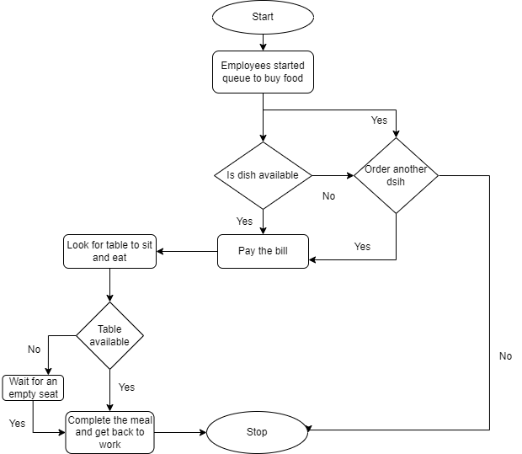

**Proposed System**

What is the proposed solution or system? Mention in points how the system itself will be for the user.

* User friendly interface
* Enrolment in the system by salary deduction
* Ease of order placement
* Variety of menu
* Order more than one order within 11:00
* No shortage of food
* Can track order details and total billing
* Choice to eat at workstation/ book space in canteen
* Provide feedback
* Management can intervene based on the feedback provided from the employees/buyers

**Scope using *use case diagram* (UML)**

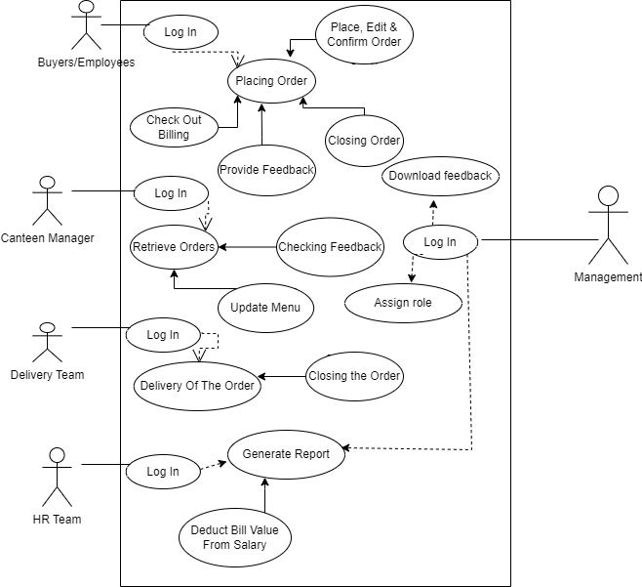

.

**Scope using *context diagram***

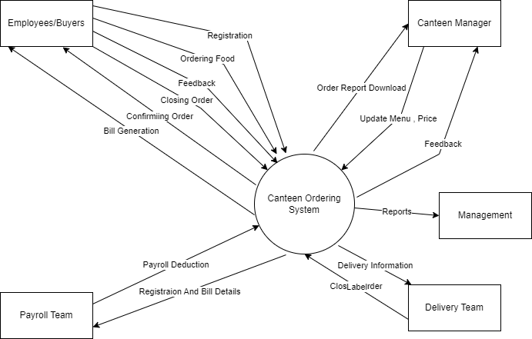

**In Scope**

* System shall support registration by employee id and deduction of order value from salary
* System shall let employee to login by employee id
* System will capture food registration, orders, feedback and bills to deduct from salary.
* System will allow maintenance
* Consolidation of orders
* Inventory management system and wastage management
* Detailed report downloads in excel/csv format from management and payroll side.
* Closing of orders once the delivery is done from delivery team’s side and employee’s’ side
* The system will be available only in Unilever UK office
* Choice of delivery i.e. delivery the food to workstation or booking a space in Canteen

**Out of Scope**

* Implementation of the system to other Unilever offices.

**Activity Diagram for the System:**

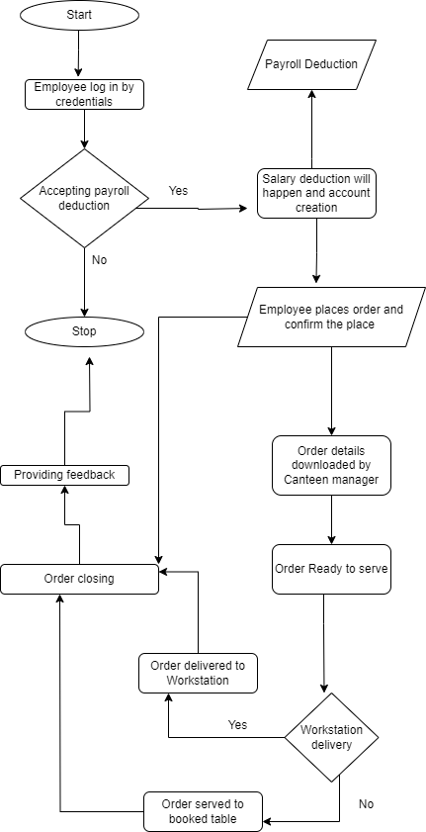

**ER Diagram for the System:**

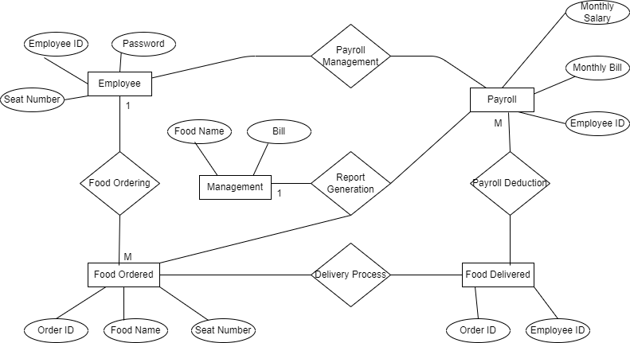

**Preconditions and Triggers: Example**

* **Preconditions: Employees/Buyers:** Need to create an account by registering with employee id and accepting of salary deduction of the bill value. They can choose the dishes from the menu without any issue. Place order before 11:00 am. **Canteen Manager:** Will have account through which the menu will be administered, Consolidated orders will be downloaded, feedback will be downloaded. **Delivery Team:** The delivery team will have all details like order, workstation details at 12:30 and can close the order from their side once the delivery is done.
* **Triggers: 1)** The employees/customer wants to order one/multiple food items. **2)** Canteen manager download the all the consolidated orders. **3)** the delivery boy will have the order details with delivery destination
* **Basic Flow:** Employees/buyers place order before 11:00 am and Canteen Manger get the order details and Delivery team will deliver the food items. Buyers shall provide feedback and Canteen manager and management will get the feedback. Depending upon feedback and order data the management will take action.
* **Elements:** Users (Employees, Canteen Manager, Delivery Team, Payroll, Management), Menu, Order, Price, Feedback
* **In case of errors, what happens:** The error goes to the management and the management will find the cause of the error and find the solution of the error.

**Business Requirements:**

**Business objective – 1:**

Reduce food wastage by a minimum of 30% within 6 months following first release.

Scale: Value of food thrown away each month by examining the canteen inventory.

Previous – 25% wasted

Must Plan For – less than 15%

**Business objective – 2:**

Reduce canteen operating costs by 15% within 12 months, following initial release.

**Business objective - 3:**

Increase average effective work time by 30 minutes/employee/day within 3 months.

**Business objective - 4:**

By making the ordering process automated and by delivering the food to the user’s workstation, the canteen will be operable with lesser manpower.

**Functional Requirements**

1. FR-1: Employee will be able to create an account by logging in with employee id. Set password. Have interface to recover password.
2. FR-2: An administrator. The administrator will assign the Canteen Manager’s account, Payroll’s account, Delivery team’s account, Buyer’s account, Management’s account (for overall report generation and error management.)
3. FR-3: Employee will be able to create the account by accepting of salary deduction of the bill value, with their employee id as login credential.
4. FR-4: Web interface to change/upload/download menu and change prices
5. FR-5: Inventory will be recorded in the system. Once the inventory is booked, it will show consumed. Also, will record wastage.
6. FR-6: Space management. Employees can book table in canteen or they can ask to deliver the food to their workstation.
7. FR-7: Role – Canteen manager can amend menus, download order details, User can place order, check billing, give feedback, Delivery team can view the list of orders provided by the Canteen manager and close the order, Management and payroll can download reports.

**Nonfunctional Requirements**

**System Requirement:**

* NF-1:The system should be low maintenance and required minimal manual intervention.
* NF-2: The system should have capacity of 1500 logins and ordering.
* NF-3: Employee need to change the password after 1 month. System will automatically route the employee to do so.
* NF-4: The system will run only on company authorized browser.
* NF-5: The system will store the order data.
* NF-6: Feedback and transactions will be stored and management can trace them.
* NF-7: The system will be light so that the employees can browse smoothly and fast.

**Usability:**

* NF-8: The system should be user friendly and self-explanatory.
* NF-9: All employees can check the menu and the prices but employees can place order only if they have account by accepting payroll deduction and logging in the system.
* NF-10: Once the new Canteen Management System go live, the old system will stop.

**Environments:** Java code to be used as it is low maintenance.

**Wire Frame:**

